Giorgos Raptis:

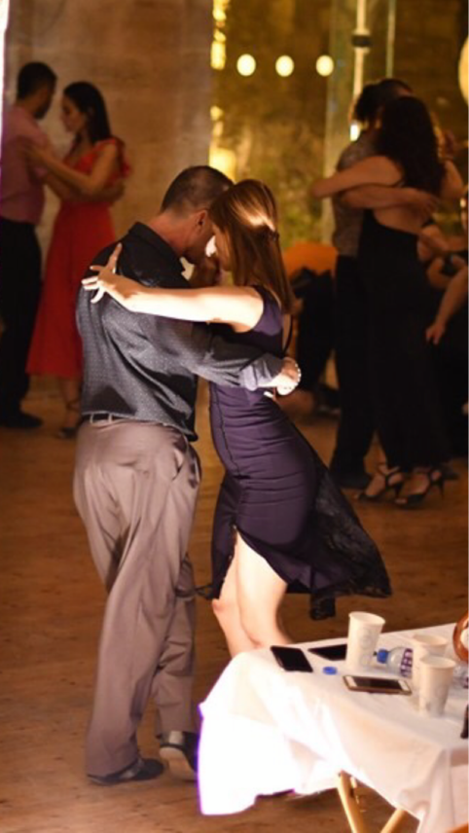Giorgos Raptis is a tango teacher since 2007. He is one of the basic teachers in Cyprus since 2010 when he moved in from Greece. Giorgos has been trained mainly in Buenos Aires where he has followed a big number of private lessons with many maestros: Jorge Firpo, Carlos Copello, Pablo Nievas and Valeria Zunino and Stanislav Fursov and Katerina Simonova. But the main influence in his dance and teaching were given by the great maestro Gustavo Naveira whom he apprenticed for almost a year, taking private lessons every day. Giorgos Raptis’ teaching methodology follows the main principles of Gustavo Naveira 's Method, enriched with his own ideas that were developed over the years.

Giorgos started as a dance couple with Stella Sifaki. In the last few years he teaches and performs with Eleanna Papadopoulou with whom he permanently explores different aspects of Tango. Together they study the posture and the preparation of the body with regards to strength and flexibility as well as the technique and geometry of the couple. Giorgos as a teacher is well known for his ability to connect the musical rhythms with the tango steps within the different tango sequences and musical styles. This gives to his students a much more in depth understanding of the dance. He believes that a dancer’s development is endless.

Eleanna Papadopoulou:

Eleanna started Tango In 2009. She learned from Giorgos Raptis with whom she now teaches, performs and continuously studies different aspects of Tango. Eleanna has a special interest in body mechanics in relation to the ease and grace of dance movements. This has driven her to update constantly her training by undertaking multiple sessions and seminars in specialized exercising systems for dancers like Pilates, Yoga, Alexander technique, Gyrotonic, and Ballet. In her Tango journey Eleanna has also taken many lessons from world recognized Maestros in the technique of steps, the structure of tango moves and the geometry of the couple. Besides, her musical background (having taken a diploma in piano by the age of 17), gives her a great understanding of musicality in Tango. Furthermore, her long-standing background as a Qualified Teacher in Chemistry Education (since 2004) gives her solid and professionally based expertise on analytical and teaching skills that she considers essential to be transferred to dancing in order to provide an all-round Tango session experience.

